Developer Lab – Amaris Foundation Website

# Context and Goal of the application:

« Amaris Foundation commits to support projects and associations dedicated to using technology & innovative solutions to help foster independence in various fields of action: Energy, Healthcare, Education, Employment, Food self-sufficiency… »

This is Amaris Foundation in brief, and in order to spread the word, to make it famous, the group need a great website. Which mean that in addition to be informative, it must convey innovation, trust and performance.

# General

## **Browser compatibility**

Provide a full support for the following browsers:

IE

Chrome

Firefox

Safari

## **Responsive design**

The website will be responsive for easy navigation no matter the screen size (desktop, tablets and smartphones)

# Screens

## **Header**

Header fix to viewport (top)

Contains:

* “Contact” button (mailto: labfoundation@amaris.com)
* “Connect” button (redirect to Propose a project page) (background become plain purple #A12A7D when user hover it)
* Amaris Foundation logo (by clicking on it, the user goes back to the homepage)
* Hamburger menu (when the menu is displayed, the 3 lines icon is changed for a cross icon (to show that you need click on it to close the menu). (animation: sliding from left to right). Links to:
  + Homepage
  + Amaris
  + Propose a project



## **Footer**

The footer contains:

* Social network icons (when clicked on one, I’m redirected to the appropriate social network)**(Facebook/Twitter/LinkedIn/Instagram)**
* Menu links
* Copyright (“Collectively crafted with love for Amaris Foundation”)

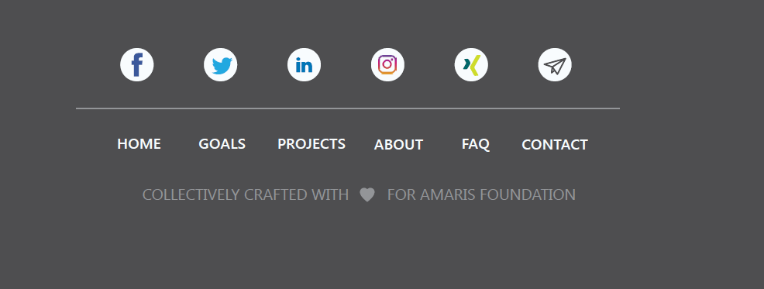

## **HomePage**

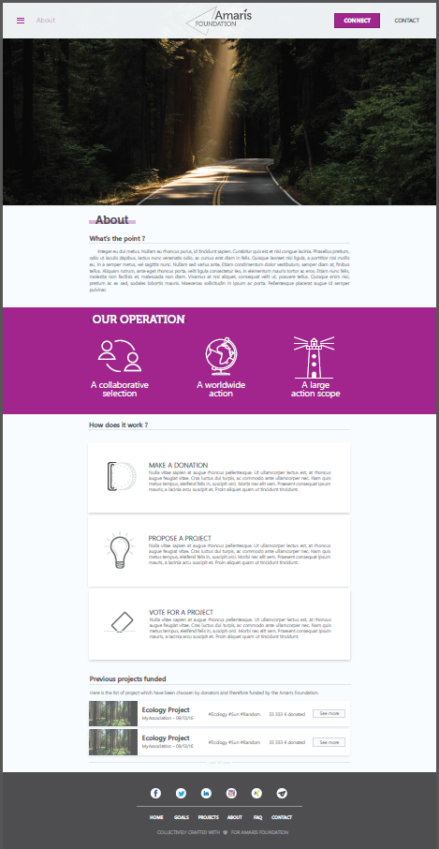

**Above the fold:** Header + BigVisual

**Colors:**

Background: #f8fcff

Purple: #A12A7D

Font: #333

Tile background: #fff

**About part:**

Simple text (can add generic text)

**Our Operations part:**

Simple text + icons (can add generic text and icons)

**How does it work part:**

Simple text + icons (can add generic text and icons)

**Previous project funded part:**

Part supposed to present few example of funded project. Each project is displayed by a tile that I can expand to get more information. (Image and text is coming from the app Foundation) (For the moment you can add generic text)

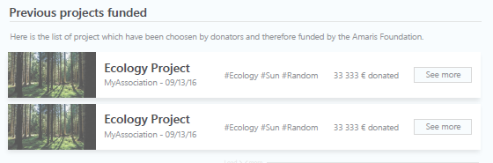

When clicking on “See more”, the tile expand (with animation):

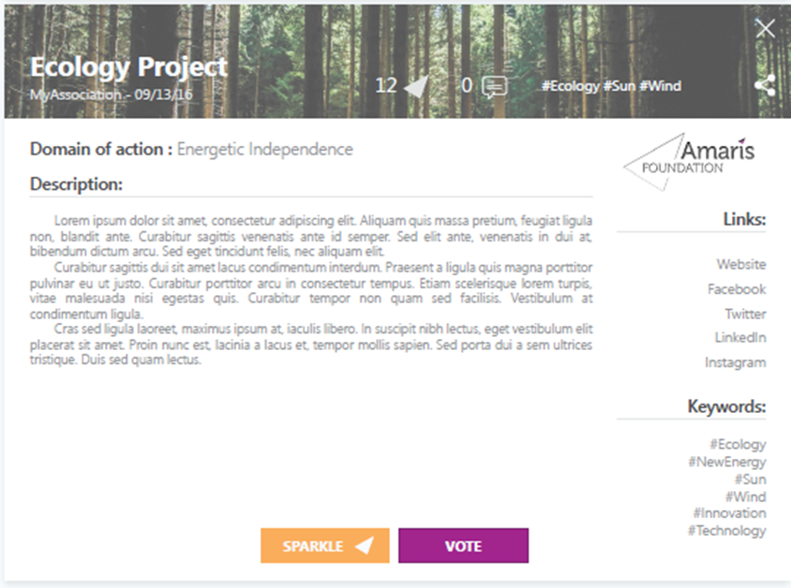

Different tiles can be expanded at the same time.

## **Propose a project page**

Page which allow organizations/companies/users to send project proposal to AmarisFoundation with the help of a form that they can fill online.

**/!\ Design of the page is up to you ! As long as you keep the content. /!\**

Questions that the user need to fill

* Project Name (Free field)(Mandatory)
* Description (Free field) (Mandatory)
* Keywords (Free field)
* Name of the organizations/companies/users (Free field) (Mandatory)
* Website URL (Free field)
* Scope of action (list selection: Scope1 / Scope2 / Scope3 / Scope4) (Mandatory)
* Logo of the project (image upload) (Mandatory)

In addition the user need to agree with the Terms&Conditions below before submitting his project:

*Rules for a non-profit organization to be selected:*

*To be selected the project of the non-profit organization needs to:*

*1. Use technology and innovative solutions to help foster independence;*

*2. Respect our rules of Ethic : no discrimination of any kind, no promotion of a political or religious organization;*

*3. Have a local, concrete and measurable impact.*

*Then submitting a new non-profit organization to the Amaris Foundation is simple: collect all the information required with the non-profit organisation then complete the form here.*

*For more details and information, take a look at the FAQ and at the Project Proposal Guidelines*

*Any questions? Any doubts? Don't hesitate to contact us at foundation@amaris.com.*